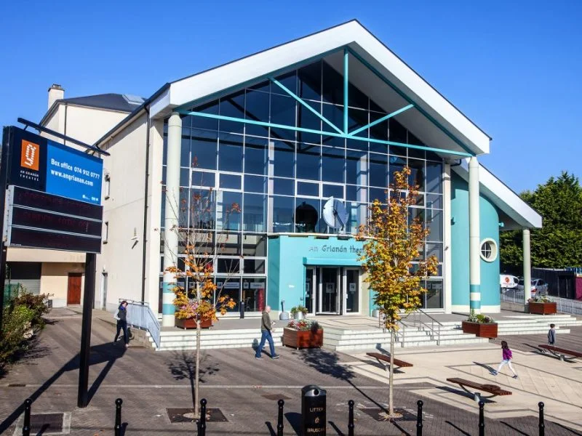

BOX OFFICE SUPERVISOR
RECRUITMENT PACK
WHO WE ARE
FIESTA 2014/15

In 2024 An Grianán Theatre celebrates its 25th anniversary. We opened in October 1999 and rapidly earned a reputation for artistic excellence and accessibility hosting over a million customers to date. Located in Letterkenny, the theatre is an integral part of the county’s thriving cultural life and a flagship venue in the Northwest of Ireland.
We give local audiences and visitors the opportunity to enjoy the very best local, national, and international arts and entertainment events. Boasting a 383-capacity auditorium and one of the largest theatre stages in Ireland, we are a state-of-the-art facility committed to presenting the best in drama, comedy, music and much, much more. We maintain a busy programme of community and outreach events including a youth theatre for children and young people that runs weekly classes during the school year. The theatre is open to the public all day and one can avail of the excellent café and bar, view art exhibitions or, of course, attend a show.
This is an exciting time to be joining An Grianán, with the theatre’s plaza undergoing a redevelopment and further investment in the building planned for 2024. The 380+ seat auditorium hosts a mixed programme of musicals, drama, comedy and children’s shows, while the Café Bar provides lays an important place in the community space, providing a relaxed environment for youth and other inclusive community groups.
The theatre building is owned by Donegal County Council and run and maintained on its behalf by An Grianán Theatre Management CLG. It is a registered charity. An Grianán Theatre receives annual funding from Donegal County Council, The Arts Council and the Department of Employment Affairs and Social Protection. It also receives project funding from the Department of Culture, Heritage and the Gaeltacht and sponsorship from Highland Radio.

WHAT WE DO
A WINTERS TALE 2019

Our Vision
An Grianán Theatre is recognised as a hub for culture, creativity, and the arts, creating excellent work and engaging communities across the Northwest and beyond through partnership and collaboration.

Our Mission
To create great art experiences in the heart of our community

Our Artistic Policy
Everything that An Grianán Theatre does is informed by our artistic policy which is driven by six key artistic ambitions:
To inspire - We will inspire the people of Donegal to unlock their creativity through our work and through the partnerships in which we engage.
To nurture - We will nurture the creative talent and ideas of artists, individuals and groups and businesses, working in partnership to enable our community to be active participants in culture and giving every person the support and encouragement to realise their creative potential.
To explore - We will explore the stories, histories and experiences of our community, our county, and our island, encouraging audiences to participate in the celebration of our distinctive voice and our unique cultural identity.
To challenge - We will challenge both audiences and participants with our programme, inspiring discovery, debate, and engagement, whether that be in-building or off-site.
To reflect - We will reflect on and evaluate our ambitions, taking account of demographic, social and environmental changes. We will make sure everyone in our community knows what we do, how to engage with us and the difference An Grianán Theatre makes.
To entertain - We will entertain our audiences with an accessible and eclectic programme of theatre, comedy, music, dance, visual arts, multi-disciplinary work and participatory arts, creating an inclusive, welcoming environment, where every member of our community has access to great art with opportunities through both English and Irish.

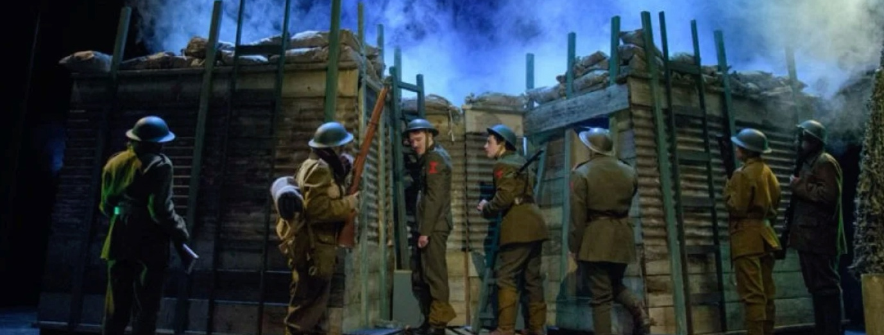
BLACKADDER GOES FORTH 2017
OUR VALUES
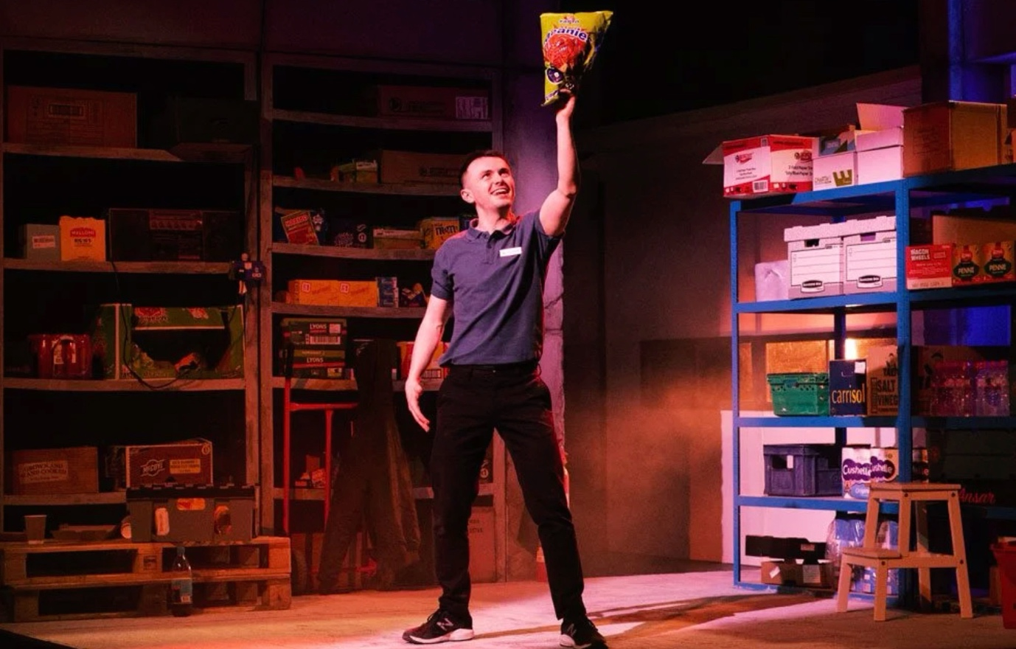
REVVED 2022

An Grianán Theatre has agreed the following values which shape its behaviour in achieving its vision and undertaking its mission, in interacting with its customers, partners, funders and other stakeholders, and in discharging its governance functions.
Value What it means to An Grianán Theatre
Responsive and proactive To ensure that An Grianán Theatre responds to the needs of our audiences, participants, our diverse communities, our partners, and our employees.
Creative and innovative We are an energetic, agile organisation ready to build on entrepreneurial opportunities as they arise and ready to embrace and adapt to changes as required.
Excellence We will strive for excellence in the creation, presentation, and mediation of arts, improving ourselves, our teams, our partnerships, and the quality of and effectiveness of our work.
Partnership We will build on our existing partnerships and develop new ones that connect us to the diverse communities and visitors in our area. We will ensure the contribution and value of arts is fully recognised and nurtured for the wellbeing of the communities of Donegal.
Sustainability focus We will work to become more sustainable, by both diversifying our income streams and delivering on our responsibilities to the planet.
Customer & outcomes focus We will continue to surpass our customers’ expectations and will contribute to making a meaningful difference to people’s lives through delivering on the outcomes of the Donegal Local Economic and Community Plan (LECP) and those of the Arts Council
Inclusive, diversity & equality focus We are a theatre for all the people in the Northwest and as such we will create dynamic and diverse opportunities to engage all in our community. We will innovatively strive to address barriers to accessibility. We are committed to delivering in both English and as Gaeilge.
A learning & respectful environment We will work as a collaborative, engaged and supportive team, respecting the professionalism and integrity of our individual roles and responsibilities. We will continue to enjoy what we do and will deliver what we do with passion and commitment. We will invest in learning and development opportunities for our staff and board and the artists with whom we work including new skills for a new emerging economy. We will respect each other’s roles as staff and board teams.

MANNY MAN DOES ThE HISTORY OF IRELAND 2018
THE ROLE

Job Title — Box Office Supervisor
Main Function of the Role: The role of Box Office Supervisor is expected to provide customer service, cash handling and ticketing services for An Grianán Theatre. It also requires the supervisor to oversee other Box Office staff and to ensure that they are providing a consistent service. This is an integral part of An Grianán’s team that involves front line daily interacting with our patrons and providing for their needs. In addition, the role requires the candidate to undertake Duty Supervision of the theatre during shows. This role requires a motivated and dynamic person who can think and operate in a strategic, methodical, well organised manner and can manage multiple priorities.
Hours - 40 Hours (Full time)
Base - An Grianán Theatre
Salary - €30, 000 - €32,000
To Apply - Please send a CV and letter (2 Pages max) outlining your suitability for the role, in particular paying attention to address the essential and (if applicable) desirable experience, skills and attributes. Please include the names and contact details of 2 referees in your application.
Send your application by email only to: pmcbride@angrianan.com

Deadline — Monday 15 April 2024 12pm.
An Grianán Theatre is committed to the principle of equality of opportunity. We will ensure that no one receives less favourable treatment on the grounds of colour, race, religious belief, political opinion, sex, marital status, disability, age, sexual orientation, family circumstance, pregnancy or maternity leave, gender, gender reassignment or ethnic or national origin. We welcome applications from all backgrounds.
JOB DESCRIPTION AND PERSON SPECIFICATION
Job Title: Box Office Supervisor
Job Role: The role of Box Office Supervisor is expected to provide customer service, cash handling and ticketing services for An Grianán Theatre. It also requires the supervisor to oversee other Box Office staff and to ensure that they are providing a consistent service. This is an integral part of An Grianán’s team that involves front line daily interacting with our patrons and providing for their needs. In addition, the role requires the candidate to undertake Duty Supervision of the theatre during shows.
Key Responsibilities include but not limited to:

Box Office Day-to-Day
- To process phone, online and in-person ticket sales and queries using Ticketsolve, An Grianán’s computerised ticketing system.
- To actively maintain and encourage a high standard of professional customer service as An Grianán’s first point of customer contact.
- To be fully informed of each event, knowing the main selling points, and looking to create sales opportunities and group development whenever possible.
- To replenish and update the marketing material in An Grianán Theatre and ensure that the Box Office and foyer area is always presentable and safe.
- To communicate with relevant departments on sold out shows, notable sales patterns, group bookings and other appropriate show and sales updates.
- Troubleshooting issues with credit card machines, printers, scanners and hearing assisted headsets.
Box Office Admin
- Making sure box office protocol is followed re reservations, disability seating, booking comments, tracking group bookings from reservation to sale, end of day protocol.
- Issuing invoices to schools and other group bookings in a timely fashion
- To coordinate An Grianán’s Youth Theatre, liaising with the facilitator; ensuring payments are made for each term and to disseminate any correspondence to the participants and their guardians as necessary.
- To effectively manage incoming companies regarding their guest lists, sales reports, other ticketing needs and recharges.
- To produce sales and marketing reports and event analysis reports when required.
- To liaise with Ticketsolve and/or IT support regarding any issues that may occur with the system, in a quick and efficient manner.
- To manage sales, reconciling reports, updating seating charts, event information, and any administration/tasks related to Box Office, Front of House or Marketing that may be reasonably required.
- To support the Marketing Officer to manage and maintain the back end of Ticketsolve, setting up and updating shows on our website, and maintaining customer databases and website recommendations.
- To proactively provide solutions to any identified problems at Box Office, including being receptive to customer feedback and using this feedback to improve our services, where appropriate

Box Office Supervision
- To help train and support all An Grianán’s Box Office Assistants and keep them informed of daily activities, updates, and developments.
- Ability to use discretion in making decisions within the scope of the role, and to liaise with line manager if guidance/assistance is required.
- To ensure that the appropriate ticketing printing system is in place for each show, considering the demographic of the show attendees.
- To communicate effectively with the Duty Supervisor on all show nights.

Duty Supervision
- To supervise other FOH staff in the delivery of their duties eg. directing the audience to their seats, serving drinks, selling merchandise including programmes and confectionery and if necessary to step in to offer support to them at busy periods. Front of House Staff includes Bar staff, Ushers, Box Office, and Cafe staff.
- Greet members of the public and visitors to the theatre, handle enquiries in person and on the telephone
- To ensure that all areas of FOH are operating efficiently - ensuring all FOH areas including toilets are clean and tidy and stocked with materials promoting forthcoming shows
- To support the duties of the box office staff, handle cash, cheques and credit/debit card transactions reconciling sales to money taken at the end of each day for box office sales and merchandise sales where appropriate.
- Liaise with the technical staff to ensure the prompt start of all performances.
- In conjunction with the technical staff to ensure that the needs of patrons with physical or intellectual disabilities are met for their full enjoyment of their visit to An Grianán Theatre eg. Wheelchair users are accommodated, assisted hearing sets are working etc.
- To act as the appointed officer in the theatre in the event of any emergency such as customer illness, fire and bomb alerts and to act as the Liaison officer with the emergency services on behalf of the theatre in such a situation and to evacuate the theatre if necessary.
- To write up an Incident Report detailing any incident or accident involving a member of staff for the public for the attention of the theatre’s Health and Safety Officer

General
- To communicate effectively with the Duty Supervisor on all show nights
- To be a key holder for the theatre building - To lock up the theatre buildings as required and ensure that the security alarm is activated.
- To attend and contribute to Marketing meetings.
- Management and updating of digital signs - roadside and internal digital signs.
- Manage enquiries from the general theatre email account info@angrianan.com

Reports to: Marketing and Business Development Manager, Marketing Officer and Venue Director
Works with: Box Office staff, Bar staff, technical staff, Admin staff, Community Employment Staff, Customers and Visiting artists and companies.

Person Specification:

This role requires a motivated and dynamic person who can think and operate in a strategic, methodical, well organised manner and can manage multiple priorities.

Essential:
- Good knowledge of ticketing systems; (Ticketsolve training is provided if necessary)
- Minimum 1 year of experience in a customer service-related industry
- Excellent positive, efficient, and courteous verbal and written communications
- Excellent cash handling skills
- Available to work evenings and weekend shifts

Desirable:
- Third-level qualification in a related subject
- Experience of using website and/or E-communications content management systems.
- Experience of working in the arts industry.

Attitudes, Skills and Abilities:
- Strong interpersonal and communication skills
- Ability to work under pressure and to deadlines.
- Flexibility to work equally well on own initiative as well as collaborating as part of a close-knit team.
- Effective time management and ability to prioritise own workload.
- High standard of attention to detail, integrity and reliability.

