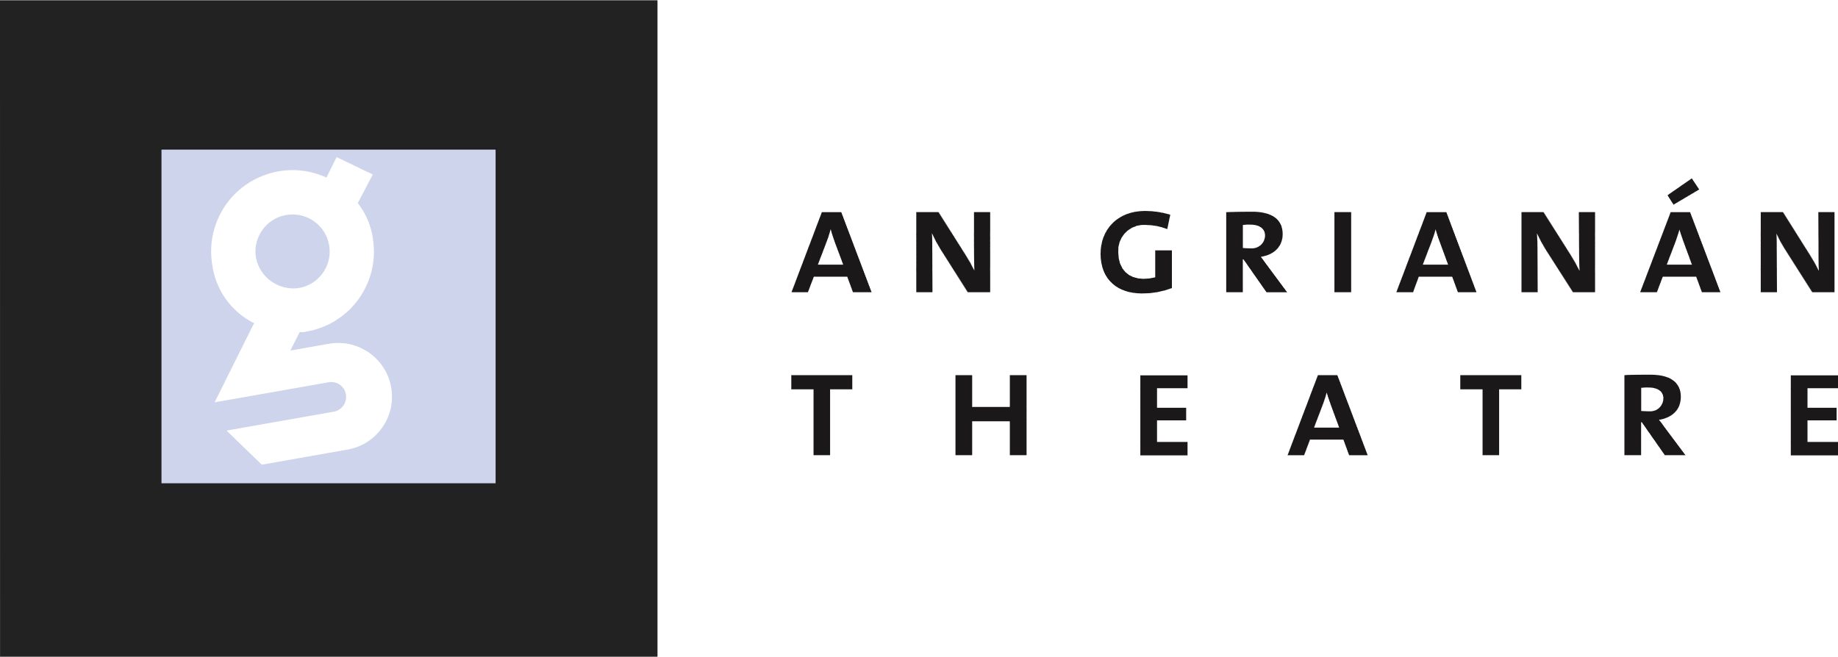

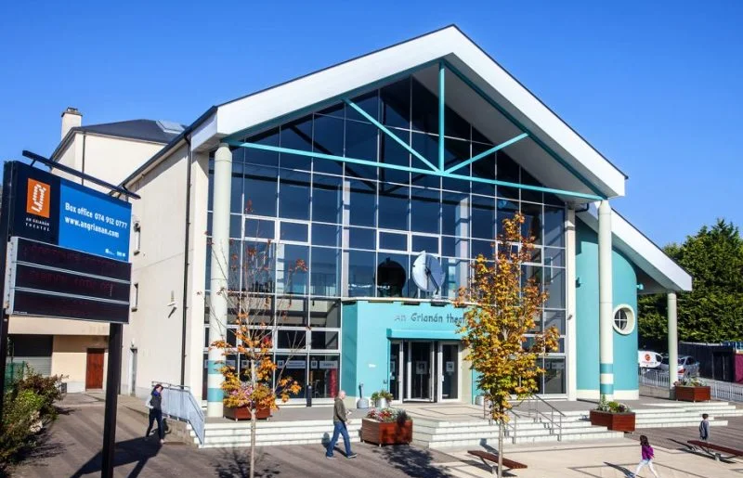

MARKETING AND BUSINESS DEVELOPMENT MANAGER
RECRUITMENT PACK
WHO WE ARE
FIESTA 2014/15

In 2024 An Grianán Theatre celebrates its 25th anniversary. We opened in October 1999 and rapidly earned a reputation for artistic excellence and accessibility hosting over a million customers to date. Located in Letterkenny, the theatre is an integral part of the county’s thriving cultural life and a flagship venue in the Northwest of Ireland.
We give local audiences and visitors the opportunity to enjoy the very best local, national, and international arts and entertainment events. Boasting a 383-capacity auditorium and one of the largest theatre stages in Ireland, we are a state-of-the-art facility committed to presenting the best in drama, comedy, music and much, much more. We maintain a busy programme of community and outreach events including a youth theatre for children and young people that runs weekly classes during the school year. The theatre is open to the public all day and one can avail of the excellent café and bar, view art exhibitions or, of course, attend a show.
This is an exciting time to be joining An Grianán, with the theatre’s plaza undergoing a redevelopment and further investment in the building planned for 2024. The 380+ seat auditorium hosts a mixed programme of musicals, drama, comedy and children’s shows, while the Café Bar provides lays an important place in the community space, providing a relaxed environment for youth and other inclusive community groups.
The theatre building is owned by Donegal County Council and run and maintained on its behalf by An Grianán Theatre Management CLG. It is a registered charity. An Grianán Theatre receives annual funding from Donegal County Council, The Arts Council and the Department of Employment Affairs and Social Protection. It also receives project funding from the Department of Culture, Heritage and the Gaeltacht and sponsorship from Highland Radio.

WHAT WE DO
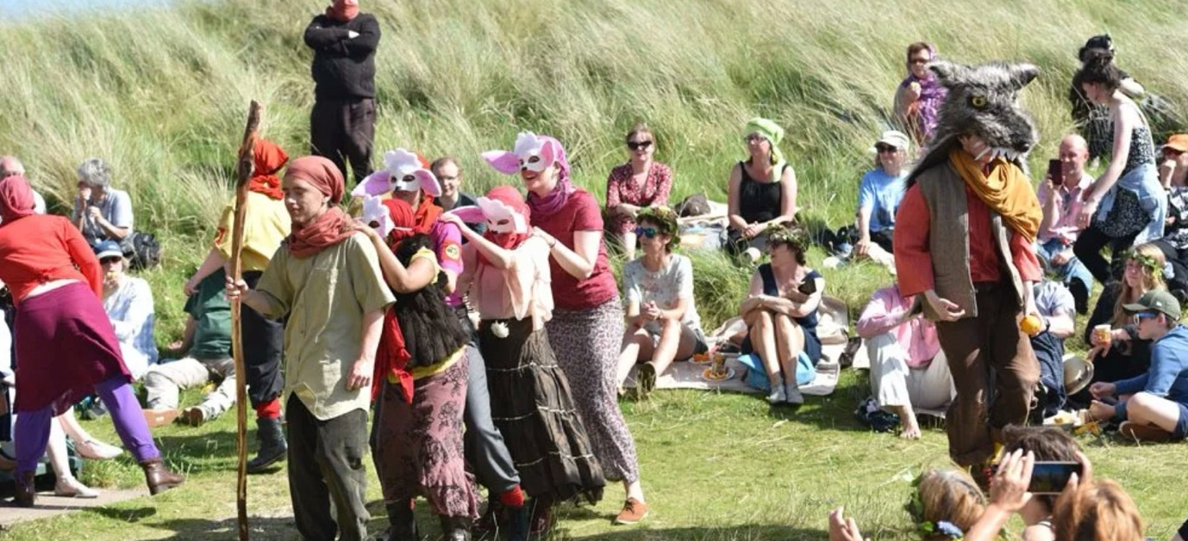
A WINTERS TALE 2019

Our Vision
An Grianán Theatre is recognised as a hub for culture, creativity, and the arts, creating excellent work and engaging communities across the Northwest and beyond through partnership and collaboration.

Our Mission
To create great art experiences in the heart of our community

Our Artistic Policy
Everything that An Grianán Theatre does is informed by our artistic policy which is driven by six key artistic ambitions:
To inspire - We will inspire the people of Donegal to unlock their creativity through our work and through the partnerships in which we engage.
To nurture - We will nurture the creative talent and ideas of artists, individuals and groups and businesses, working in partnership to enable our community to be active participants in culture and giving every person the support and encouragement to realise their creative potential.
To explore - We will explore the stories, histories and experiences of our community, our county, and our island, encouraging audiences to participate in the celebration of our distinctive voice and our unique cultural identity.
To challenge - We will challenge both audiences and participants with our programme, inspiring discovery, debate, and engagement, whether that be in-building or off-site.
To reflect - We will reflect on and evaluate our ambitions, taking account of demographic, social and environmental changes. We will make sure everyone in our community knows what we do, how to engage with us and the difference An Grianán Theatre makes.
To entertain - We will entertain our audiences with an accessible and eclectic programme of theatre, comedy, music, dance, visual arts, multi-disciplinary work and participatory arts, creating an inclusive, welcoming environment, where every member of our community has access to great art with opportunities through both English and Irish.

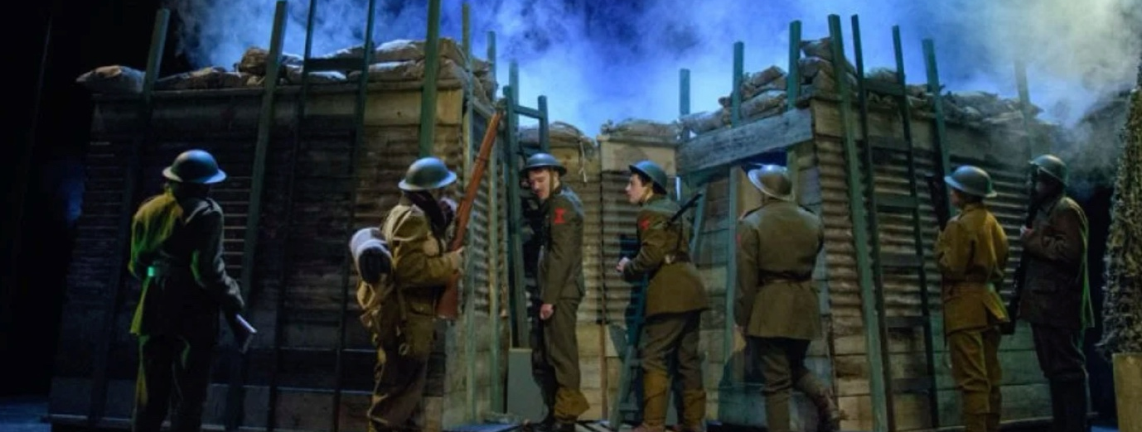
BLACKADDER GOES FORTH 2017
OUR VALUES
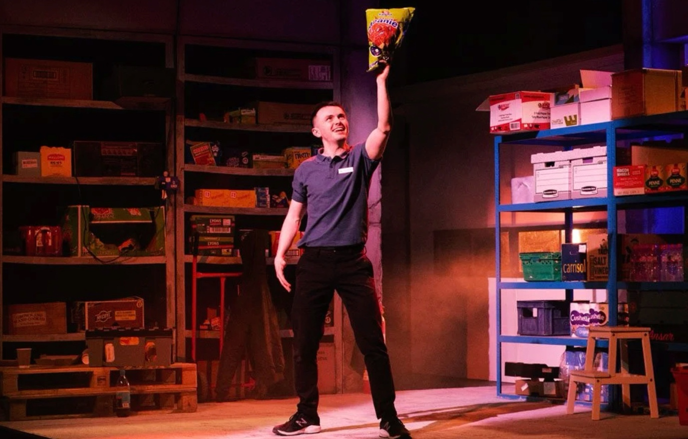
REVVED 2022

An Grianán Theatre has agreed the following values which shape its behaviour in achieving its vision and undertaking its mission, in interacting with its customers, partners, funders and other stakeholders, and in discharging its governance functions.
Value What it means to An Grianán Theatre
Responsive and proactive To ensure that An Grianán Theatre responds to the needs of our audiences, participants, our diverse communities, our partners, and our employees.
Creative and innovative We are an energetic, agile organisation ready to build on entrepreneurial opportunities as they arise and ready to embrace and adapt to changes as required.
Excellence We will strive for excellence in the creation, presentation, and mediation of arts, improving ourselves, our teams, our partnerships, and the quality of and effectiveness of our work.
Partnership We will build on our existing partnerships and develop new ones that connect us to the diverse communities and visitors in our area. We will ensure the contribution and value of arts is fully recognised and nurtured for the wellbeing of the communities of Donegal.
Sustainability focus We will work to become more sustainable, by both diversifying our income streams and delivering on our responsibilities to the planet.
Customer & outcomes focus We will continue to surpass our customers’ expectations and will contribute to making a meaningful difference to people’s lives through delivering on the outcomes of the Donegal Local Economic and Community Plan (LECP) and those of the Arts Council
Inclusive, diversity & equality focus We are a theatre for all the people in the Northwest and as such we will create dynamic and diverse opportunities to engage all in our community. We will innovatively strive to address barriers to accessibility. We are committed to delivering in both English and as Gaeilge.
A learning & respectful environment We will work as a collaborative, engaged and supportive team, respecting the professionalism and integrity of our individual roles and responsibilities. We will continue to enjoy what we do and will deliver what we do with passion and commitment. We will invest in learning and development opportunities for our staff and board and the artists with whom we work including new skills for a new emerging economy. We will respect each other’s roles as staff and board teams.

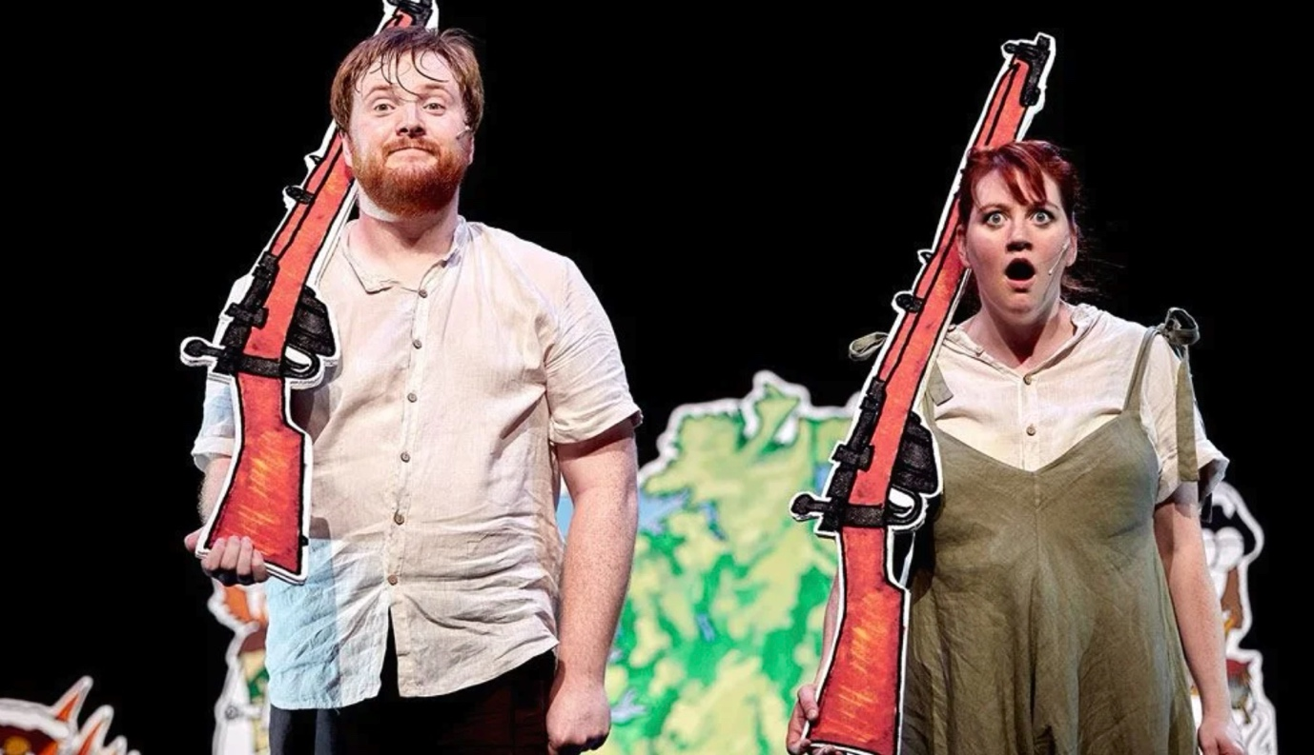
MANNY MAN DOES ThE HISTORY OF IRELAND 2018
THE ROLE

Job Title — Marketing and Business Development Manager
Main Function of the Role: This is an exciting new role within the organisation. An Grianán Theatre is looking for a dynamic and creative Marketing and Business Development Manager who will lead the marketing and commercial development of the theatre. It is a public facing sales and communications role that will be responsible for the delivery of an effective Marketing and Business Development strategy for the theatre and its activities. The successful candidate will join a hard-working team who operate in a positive, supportive environment and who care deeply about the organisation’s vision, mission and values.
Hours - 40 Hours (Full time)
Base - An Grianán Theatre
Salary - €40, 000 - €45,000
To Apply - Please send a CV and letter (2 Pages max) outlining your suitability for the role, in particular paying attention to address the essential and (if applicable) desirable experience, skills and attributes. Please include the names and contact details of 2 referees in your application.
Send your application by email only to: pmcbride@angrianan.com

Deadline — Monday 15 April 2024 12pm.
An Grianán Theatre is committed to the principle of equality of opportunity. We will ensure that no one receives less favourable treatment on the grounds of colour, race, religious belief, political opinion, sex, marital status, disability, age, sexual orientation, family circumstance, pregnancy or maternity leave, gender, gender reassignment or ethnic or national origin. We welcome applications from all backgrounds.
JOB DESCRIPTION AND PERSON SPECIFICATION

Job Role: Reporting to the Director and operating as part of An Grianán Theatre's senior management team, this is a public facing role that will be responsible for the delivery of an effective Marketing and Business Development strategy for the theatre and its activities. Working closely with the Marketing Officer and Box Office Supervisor, the Marketing and Business Development Manager will devise, cost, and put into effect schemes and projects to drive sales, diversify audiences, fundraise and generate income for An Grianán Theatre.

Marketing and Communications
- To devise and implement a marketing strategy for the theatre.
- To liaise with press and media locally and nationally including writing press releases, web page updates and blogs etc.
- To initiate and devise sales promotions for all facilities within the theatre.
- Insertion of advertisements in newspapers and periodicals and media subject to budget allocated.
- Arranging publicity photo shoots, media interviews and press launches
- Supervise and edit the season brochure copy - prioritising events and space required for events - proof reading etc. Final oversight and sign off for season brochure.
- Liaising with other staff members, ensuring good communications throughout the organisation
- To liaise with and support local amateur groups and societies in the promotion of their productions, especially in the weeks prior to show dates.
- Managing and maintaining excellent working relationships with our partner organisations, co-producers, promoters, stakeholders and funders as well as press and media, influencers and other third party communication channels in order to share insights and learning, support audience development and engagement and inform strategy.
- Report to the Theatre Board of Directors’ meeting as necessary
- Represent the organisation at events and conferences and to act as spokesperson for the theatre as necessary.
- Assist with An Grianán Theatre’s social media platforms – currently Facebook, Twitter, Instagram, Tik Tok - creating engaging content and optimising advertising campaigns for awareness, engagement and conversion.
- Contribute to email marketing campaigns and website content and monitor performance to provide a creative, engaging and effective interface for our audiences.

Business Development
- Promote the use of An Grianán Theatre and its facilities for commercial hire including but not restricted to conferences, launches, concerts etc.
- Working with the Café/Bar Supervisor to promote its services to An Grianán Theatre patrons and sponsors such as pre- and post-show food and drinks receptions etc.
- Promote strategies to increase income generation, sponsorships and donations.
- Identify potential sponsors for the theatre and its projects.
- Engage with community groups, social clubs and schools to create loyalty schemes and generate group bookings for events.
- Develop a patron loyalty programme.
- Create outreach programmes which complement the theatre’s programme of arts activities both in the theatre and off site.
- Support the Director with reports and funding applications to the Arts Council, Trusts and charities.
- Assist the Director with grant applications for capital projects and other initiatives to enhance audience experience.
- Devise and implement feedback processes for patrons and groups relating to user experience, facilities, technical, customer service and costs of using the theatre.
- Meet and exceed goals which the Director will implement for this role from time to time
Reports to: Theatre Director
Direct reports: Marketing Officer and Box Office Supervisor

PERSON SPECIFICATION

The successful candidate will be a hardworking and enthusiastic individual with a flair for marketing communications and a commitment to creating business development opportunities for An Grianán Theatre

Essential:

- A minimum of 3 years’ experience of planning, executing, and supporting Marketing campaigns.
- A minimum of 3 years’ experience of successful business development, fundraising and income generations strategies
- Experience of leading teams
- Fluency working with analytics and data to assess performance.
- Excellent standard of written and spoken English.
Desirable:
- Third-level qualification in a related subject
- Experience of using website and/or E-communications content management and ticketing software systems.
- Design and video editing skills
- Experience of working in the arts industry.
- Experience working with European Funding Organisations such as SEUPB / Creative Europe.

Attitudes, Skills and Abilities:
- Strong interpersonal and communication skills
- Flexibility to work equally well on own initiative as well as collaborating as part of a close-knit team.
- Effective time management and ability to prioritise own workload.
- Keen attention to detail, ensuring the final quality of content.
- Proactive approach and enthusiasm for developing and sharing creative ideas.
- Commitment to achieving high-quality outcomes and a determination for results.
- Desire to learn and master different skills and areas of work.

